Robot Minesweeper Help
There are several ways we can approach this – do we use our ultrasonic sensors, or do we use light sensors? Let us look at both these approaches.

Using an Ultrasonic (sonar) Sensor
If you use only an Ultrasonic Sensor, you could use a program plan like this:-
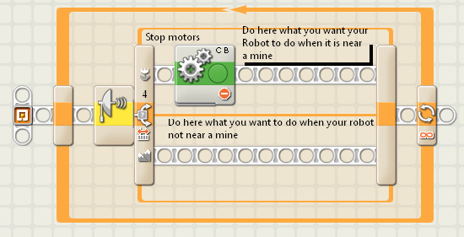
The control block for the Ultrasonic Sensor could look like this:-
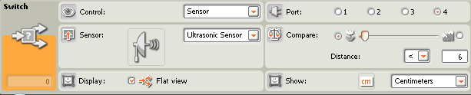

Using a Light Sensor
If you use only one Light Sensor, you could use a program plan like this:-
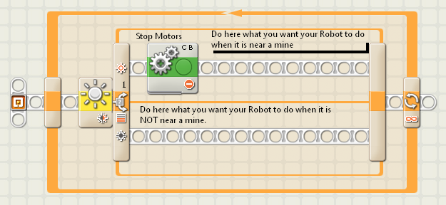
The control block for the Light sensor could look like this:-
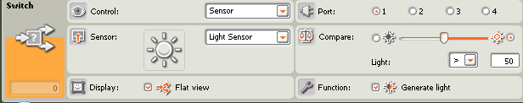

Using two Light Sensors
If you wanted to use two Light Sensors, you could use a program plan like this:-
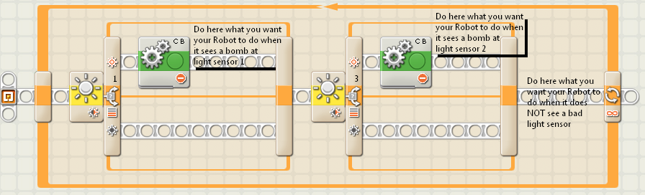
Copyright Dr. Graeme Faulkner. Lego MindStorms NXT Robot Tutorial Challenge 58 - Minesweeper - www.DrGraeme.net

