Teaching your Robot to Bullfight…
First, we want to get our Robot from the little blue square into the bullfighting ring.

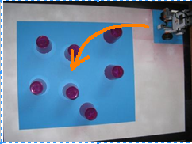
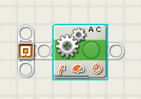

Next, how can our Robot see a Bull with its Ultrasonic sensor?

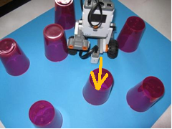

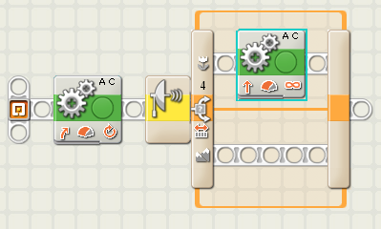

The code on the right, above, will teach our robot to charge a Bull if the bull is straight ahead of our robot in the Bullfighting ring. Good!
Unfortunately our Robot will charge straight over the edge of the bullfighting ring. Bad!

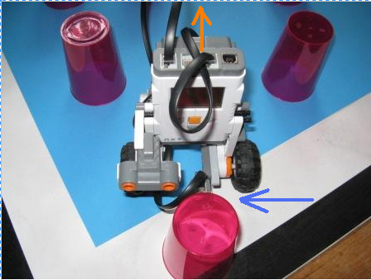
We need to be able to instruct our Robot to stop charging forward when our Robot’s light sensor sees the white surrounds of the blue bullfighting ring. In the diagram to the left, the light sensor has just left the bullfighting ring (see the blue arrow). How do we instruct our Robot to go backwards in the direction of the orange arrow, back towards the safety of the centre of the ring?

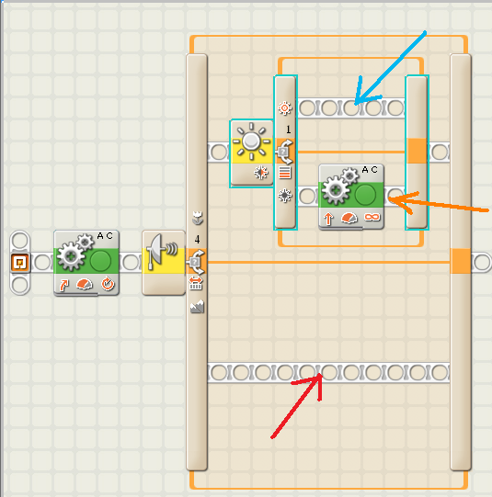
The orange arrow instruction will tell our robot to only go forward while its light sensor sees the dark blue bullfighting ring.
When our Robot’s light sensor sees white, it will go to the instruction line indicated by the blue arrow. What do we want our Robot to do when it see the white edge of the bullfighting ring? When we decide what we want our robot to do at the edge of the ring, we can put those instructions where the blue arrow points.
But what if our Robot’s ultrasonic sensor does not see any Bulls?

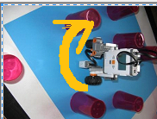
If our Robot does not see any Bulls, we will want to change the Robot’s position so that it can see any Bulls that are left in the ring. Perhaps we could instruct our Robot to turn around until it sees a Bull? The code for this could be placed where the red arrow in the diagram above is pointing. How could we tell our robot to turn around?

Finally, of course we would want to place the whole code inside a loop, so our Robot can keep looking for Bulls, and pushing them out of the ring, right up until the time when we pick up our Robot and turn it off, with its task well and truly done!

