Challenge 54 – Bull in the Ring!

Bullfighting was pictured on a wall painting at Knossos in Crete that archaeologists said was painted about 2000 BC, so it has been around for a long time.
Bullfighting is still practiced today in countries that have some Spanish history. The bullfighter on the right is Cristina Sánchez, the first female Spanish bullfighter, who retired in 1999.
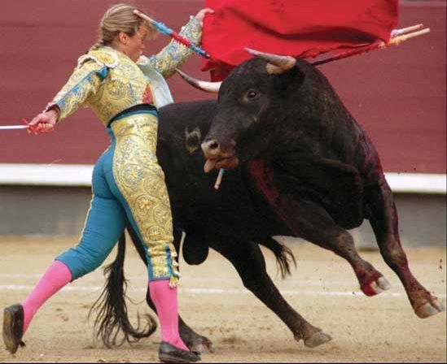

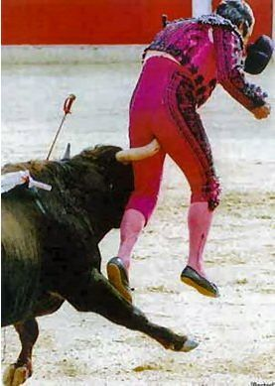
A lot of people think bullfighting is cruel. Pope Pius V forbad it in the year 1567, but his decision was so unpopular that Pope Gregory XIII allowed it again 6 years later. People still disagree about whether bullfighting should be allowed or not.
Well, we will not ask you to fight a bull – bullfighting is dangerous (see the picture to the left), so why not try a safer and gentler form of Robot Bullfighting?

Robot Bullfighting…
To make our Robot Bullfighting a little gentler, we will not ask our Robots to kill the bulls, just pushing them out of the ring will be enough – much kinder! Since it is difficult to find bulls small enough to fit into our bullfighting arena, we will use plastic cups to represent the bulls. Since these bulls can not move, we will make things a little harder for our Robots by increasing the number of bulls from the usual bullfighting number of six to seven, and we will change the ring to a square to make the bullfighting arena bigger and thus making the bulls a bit harder for our Robots to find. Our final bullfighting arena will look like the picture on the next page.

Building Our Robot Bullfighter.
It is a good idea to build your Bullfighter Robot so that it fits into an 18 cm. cube – which is about the same size needed for RoboCup Junior Rescue Robots – so building a robot this size will be good practice for future RoboCup Rescue competitions! To help you, the square the robot starts from in the arena diagram below is 18 cm. square. The Robot Cleaner you used in Challenge 16 or Challenge 50 could be a good start for building your Bullfighter Robot.
However if your mentor or teacher agrees, any size of robot can be used – the main idea is to have fun learning how to teach your robots to do what you want them to do. For example, you could decide to build a Robot Bull instead of a Robot Bullfighter to push the other bulls out of the ring – check the YouTube reference at the end of this document for ideas.
Robot Bullfighting Rules

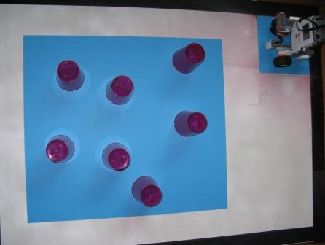
Typical rules used in Robot Bullfighting are:-
- Your Robot starts from the small blue 18 cm. square at the lower right side of the Bullfighting arena.
- The Robot has to go to the central blue bullfighting arena, and stay within that arena during the entire bullfight.

- A maximum of 2 minutes is allowed for each bullfight.
- The bullfighter must push the bulls completely outside the bullfighting arena – even a small amount of the bull still within the blue arena means that it is not counted as being outside.
- If the robot leaves the bullfighting arena, going completely outside this arena, it is picked up and started again from the small blue square, and another bull is added to the central arena (provided there are never more than 7 bulls and your robot in the arena at once).
However if your mentor or teacher agrees, you can change any of these rules any way you like, you can even make up rules that are completely your own – the main purpose is to have fun while learning about robotics!

Teaching your Robot Bullfighter.
Think about where you want your Robot Bullfighter to go after it starts. What is the easiest way to instruct your robot to get to the central arena? What is the easiest way to teach your robot to stay in the central arena? What is the easiest way to teach your robot to push all the bulls out of that arena? Is the easiest way the best way? Is your robot securely built – will it fall apart before finishing three bullfights?
If you are not too sure how to teach your robot to follow your instructions, click here for help.

Competing?
If you wanted to have a competition:-
- The best Robot could be the one with the least bulls in the arena at the end of 2 minutes.
- If the number of bulls in the arena is the same, the result is a draw.
- If the best robot can not be decided after a round of two bullfights each, a third bullfight with no time limit could be held, with the robot that clears all the bulls out of the arena in the shortest time being considered the best Robot.
But as we said above, feel free to change these rules if your teacher agrees, even make up your own if you like!

Desperation???
If you are out of ideas about how to do this, you could get some ideas by clicking on the YouTube link below and perhaps build a Robot Bull instead of a Robot Bullfighter – however if you decide to build this, you would need to get your teacher to agree to your building a robot bigger than one that would fit into the 18 cm. square; but hey, this is fine if both you and your teacher agree!
http://au.youtube.com/watch?v=8CwCSfbZFCc&feature=related

Go build your Robot Bull or Bullfighter!

Have Fun!

Enjoy!

