How Far Can Your Robot Throw?

During medieval times, attacking armies used catapults like the one below to throw stones at castle walls, hoping to break them.
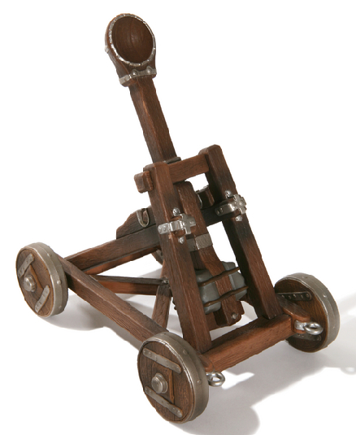
Some catapults had slings on the ends of the throwing arm; they were called trebuchets; sometimes they were better.
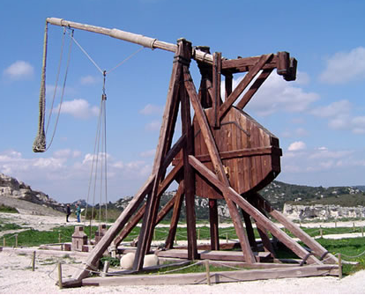
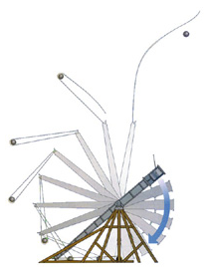

Well, we will not build a device to throw stones; people might get upset if we made holes in the walls around us! We will throw marshmallows instead of stones. The contraption that throws the marshmallow the furthest is the champion…

Robotic Mediaeval Marshmallow Throwing Devices
We will build these from our Lego NXT MindStorms kits. We can add some string or fishing line if we plan to build a trebuchet instead of a catapult.
Robotic Mediaeval Marshmallow Throwing Contests – Their Rules
Believe it or not, there are standard rules for this type of contest! Some of the rules that are often used are listed below.
The purpose: To throw your marshmallow as far as possible.
The arena: A start line on any bit of floor that does not mind marshmallows being scattered over it.
Making the robots: You can use bits from your MindStorms kit to build a robot powered only by Lego motor(s) - plus about a metre of string or fishing line if you want to make a trebuchet instead of a catapult.
The start of a bout: The robots will be placed behind the start line.
During the contest: Once a marshmallow is launched, your machine must stop moving by itself. If your machine falls over during or after throwing your marshmallow, you will lose that contest.
Robotic Mediaeval Marshmallow Throwing Contests – Our Rules
However since this is just for fun, you can use any of the rules above that you and your teacher like – you can even make up your own rules!

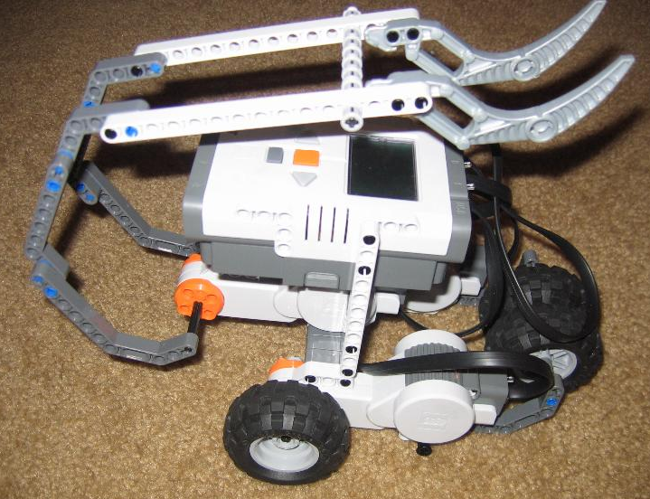
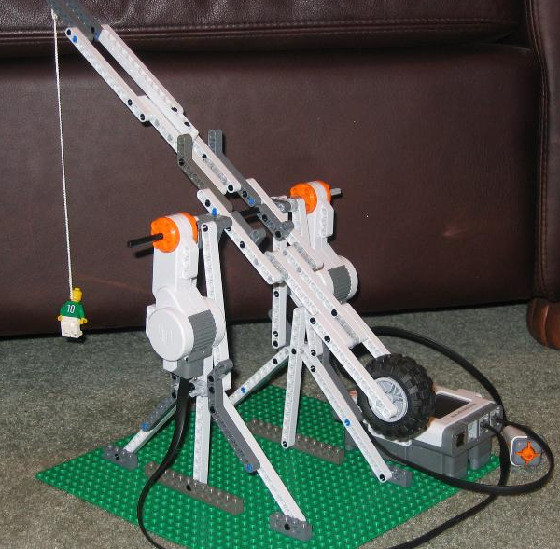

Desperation – Out of Ideas?
Some builders have made their contraptions a bit special – some catapults started when the word “fire” was shouted! Others threw when they “saw” (using their ultrasonic sensors) something in front of them, or when a touch sensor was touched. Can you think of any other way to make your mediaeval thrower special? You could also take a look at the following YouTube videos…
http://au.youtube.com/watch?v=pZH6WlGQ0ZU and/or
http://au.youtube.com/watch?v=wESdV45ymMs and/or
http://au.youtube.com/watch?v=jzWZnH781Zs and/or
http://au.youtube.com/watch?v=YHjTHrvdeD4 and/or
http://au.youtube.com/watch?v=K4qAbRunbQg .
Start Building & Throwing! - May the best robot win…

To read the complete rules go to http://www.fhsu.edu/scimathcenter/LEGO%20Documents/lego.shtml and left mouse click on the heading “Announcements and Rules 2009” to get the Microsoft Word document that contains these rules.

