Mentor Notes- Challenge 4
Greeting An Alien
Summary: These notes have four sections. The first provides some Internet links to background information relating to Aliens. The second provides information on teaching the Robot Ambassador to approach and retreat from the Alien. The third provides suggestions for the construction of the Arena on which the action takes place. The fourth contains some suggestions about possible construction of the Alien.
- Alien Background
Well, when looking for web resources on this subject, I was just about overwhelmed! It seems a lot of people want to believe in the existence of Aliens. The following notes probably contain much more information than you will need unless you are VERY interested, but you may perhaps find something to stimulate thought.
- Want to greet an Alien by sending an Alien greeting card? Maybe here or here.
- Feeling affectionate and want to send a Valientine card? Maybe here!
- There were lots of images suggesting some politicians were aliens, one of the more printable examples was (Ex-)President Bush supposedly greeting an alien (said by one of the people commenting to be Tony Blair!). It can be seen here.
- Want to know what an Alien landscape might look like? Maybe here.
- Want some Alien colouring-in images for your class? Maybe here.
- Want a randomly-generated Alien name for your students? Maybe here.
- Want an Alien ring-tone for your mobile? Maybe here.
- Not satisfied with a ring-tone, and want a complete song about Meeting an Alien? Maybe here.
- Some of the most useless advice on the Internet is given to the question “How would I greet an alien if I meet one” here.
- There is also an “Official Abductee’s Handbook” about which one reviewer comments “Actually I should be happy that something this bad could be published; it gives me hope that mine will find a publisher”, you can purchase this for $US0.03 here.
- In an April 19, 2002 entry, a blogger comments here, “For a standardized test, we were presented the question: ‘If you were on the first mission to greet an alien race, What three things would you bring from earth to make peace with them?’ My answer, and new philosophy: ‘Simply, the three things that fix anything: love, time & duct tape.’ ".
On a (slightly) more serious note, it is claimed here (paragraph 2) that “Today – ‘UFO’ [Unidentified Flying Object] ranks as the second most Googled word and scores the second highest hit just after ‘porn’ – three in every five people believe our planet has been visited by an alien civilization – there’s even an US government funded program (SETI) to look for little green men.” The SETI (Search for Extra-Terrestrial Intelligence) project is sponsored by many reputable organizations (see here), their website is here, and a Wikipedia article on SETI can be read here.
The possibility of life outside Earth has also produced religious thought. There is a course offered about (amongst other topics) “how Jews might … greet an alien being visiting Earth” here.
The University of Wyoming is offering a creative writing course about “What to say to E.T. [Extra-Terrestrial]” here, a comment about the course can be read here.
People’s need to believe in aliens may perhaps be seen in the famous reaction to Orson Welles radio dramatization of H.G. Wells’ “War of the Worlds” fantasy, which reportedly caused panic and jammed roads as people fled from New York, see an article about this phenomena here.
- Teaching your Greeting-an-Alien Robot
NXT-G: The main approach, and the approach suggested by Lego as being the easiest to learn, is to teach your Robot how to behave using the NXT-G language.
Instructions will vary, according to how far your Robot starts from the Alien. The instructions for teaching the Robot to circle the moon in the Arena I used are:-
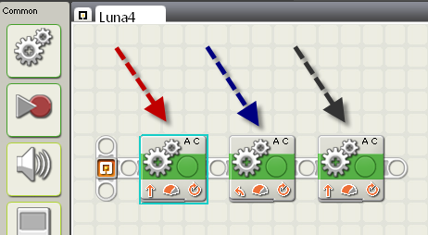
The command panel for the icon indicated by the red arrow is:-
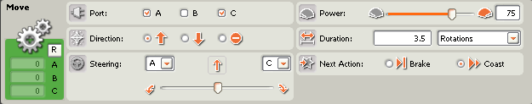
The command panel for the icon indicated by the blue arrow is:-
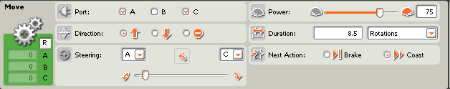
The command panel for the icon indicated by the black arrow is:-
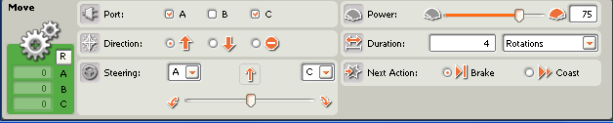
- Construction of the “Greeting An Alien” Arena
In this case all that is needed is a couple of taped lines on the floor – ordinary masking tape would be fine. One tape line could be for the Robot Ambassador to start from. The second line would be the one the Robot Ambassador has to cross before the Alien can “hear” the Robot Ambassador. A taped cross on the floor could mark the place for the Alien to stand.
Since I travel between schools, the Arena I used consisted of a straw board [1] with a sheet of cardboard [2] fixed to it to represent the “red carpet” for the Alien to stand upon. The red cardboard was fixed to the strawboard with double-sided Scotch or similar transparent plastic tape, but I imagine using any standard liquid glue would probably be fine.
The advantage of this arrangement for me is that I am ready to start when first entering the classroom, and cleaning-up at the end of the session is minimised (remember I’m a guest in the classrooms in which I mentor).
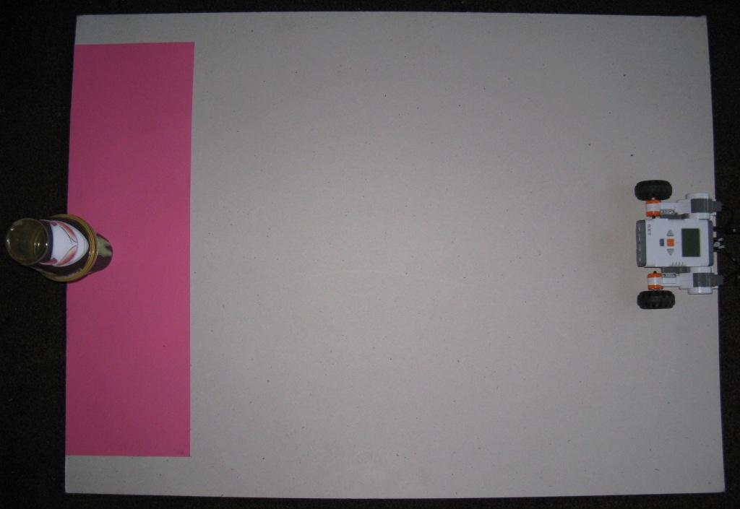
The distance from the right-hand edge of the Arena to the start of the red area is about 80 cms. (2 feet 7 ½ inches). The NXT-G instructions in the previous section worked for me at this distance.
- Construction of the “Alien”
You can probably make a far more convincing “alien” than I could quickly manage – it might even be a useful classroom art project!
I used two plastic cups [3] with print-out stuck to them with double-sided transparent tape. The images I used were:-



You could also use the previously-mentioned “colouring-in” alien images prepared by your students for this purpose, again perhaps a useful class activity, depending on your Grade.
Obtainable Where?
The following information is included to provide an idea about price & availability - it is not intended to be a recommendation for any particular commercial institution. The prices were current at the end of 2008.
[1] The strawboard is a sheet of thickish cardboard, 1050 mm by 800 mm (3 feet 5 inches by 2 feet 7 inches). Straw boards were obtained from an Art supplies Store; (in my case “Artery”, Collins Street, Hobart, Tasmania $4.95).
[2] The red cardboard sheet can be obtained from an Office Supplies shop or an Art Goods supplier; (in my case Officeworks had a limited selection of colours and sizes at $1:38 each, Artery had a much more extensive selection of colours and sizes, at prices ranging from $2.10 to $2.56). In this case I used a sheet of cardboard cut approximately in half, so one sheet could suffice for two Arenas.
[3] The plastic cups were obtained from a “remainder store” (in my case “Chickenfeed” – 10 cups for $2).

Note that, while these web sites are all free to look at, some will cost money if you want to use the products advertised, and since I haven’t purchased anything from these sites, I can’t personally recommend them.
http://www.iwasabducted.com/aliengreetings/aliengreetings.htm
http://www.funnygreetings.net/html/Alien-Greetings.html
http://www.zazzle.com/alien_valentine_card-137380742172843718
http://www.disclose.tv/action/viewphoto/158/Bush_Shaking_Hands_with_an_Reptiloid_Alien/
http://www.redbubble.com/groups/alien-worlds-and-landscapes
http://www.printactivities.com/ColoringPages/Aliens/Alien-Coloring-Pages.html
http://webspace.webring.com/people/pz/zircher/ang3.htm
https://www.audiosparx.com/sa/summary/play.cfm/sound_iid.16733
http://macjams.com/song/50012
http://www.amazon.com/Official-Alien-Abductees-Handbook/dp/0836227603
http://intelligentsingaporean.wordpress.com/2007/08/09/are-we-all-alone-%E2%80%93-a-national-week-message/
http://www.seti.org/about-us/
http://www.seti.org/Page.aspx?pid=1241
http://en.wikipedia.org/wiki/SETI
http://www.jtnews.net/index.php?/news/item/5100/C22/
http://www.csmonitor.com/2008/0515/p20s01-woam.html
http://wholly-writ.blogspot.com/2008/05/how-to-greet-alien.html
http://www.war-of-the-worlds.org/Radio/Newspapers/Oct31/NYT.html

