Mentor Notes – Robot Racing – NXT-G

Purpose
The purpose of this Challenge is to extend on the “dead reckoning” skill developed in the “Fast Robot Floor Cleaner”, and the “single motor commands” & “loops” introduced in “Lucky or Unlucky” by using all of these in combination with “conditional loops” (if a loud noise is heard then start some action; if no noise is heard, do nothing).

Detail
These mentor notes assume that the Robot is Robot2, and it also assumes that the Robot starts in the position shown in the image below.
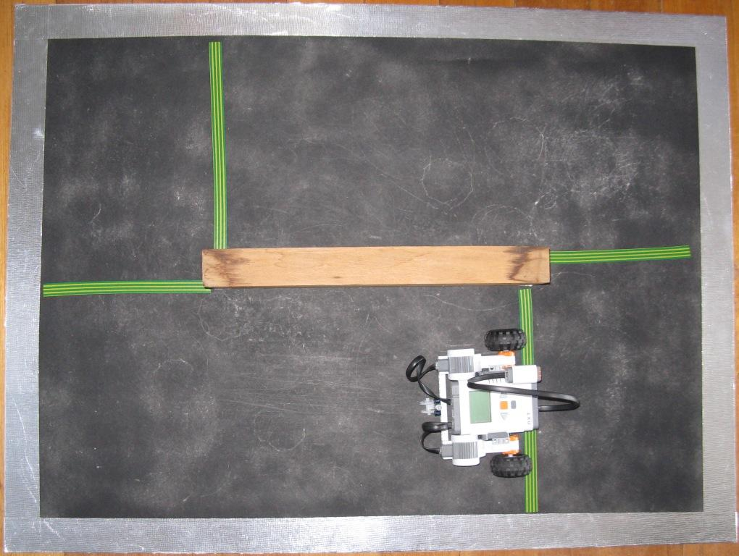
Note that Robot2 is rather large for this race course, and the students will probably be well rewarded if they are entrepreneurial and build a smaller Robot that will navigate the course more easily.
These mentor notes will use the “single motor”  option to turn the robot, mainly because this will permit numbers to be shown in the control panel, allowing more exact mentor notes. Using the “double motor”  option is also a good option - especially if you are using a bigger arena than the one used in these mentor notes.
When planning how to tackle the course, it is convenient to break the overall task into smaller tasks, such as just reaching the next green/yellow line. Let us take this route.
Reaching the first green/yellow line.
One possibility (you may find others that work better) is:-
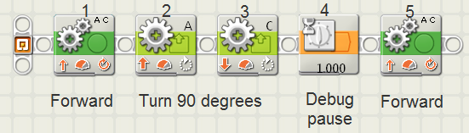
Where the command panels are:-
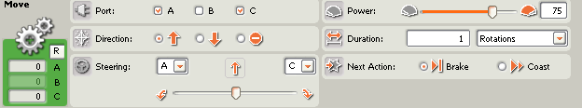 (1)
This directs the Robot to go forward one rotation of the main wheels.
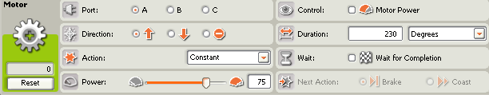 (2)
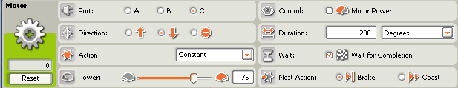 (3)
These two commands spin the Robot approximately 90 degrees. N.B. Note that in (2) the “Wait for Completion” item has been cleared – if this is not cleared, the turn will happen in two parts (try it & see!)
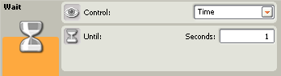 (4)
This is a “debugging pause” – it stops the Robot, so the direction in which it is facing can be checked. If it is facing in a non-preferred direction, panels (2) & (3) can be then be adjusted. If it is OK, then no adjustment needs to occur.
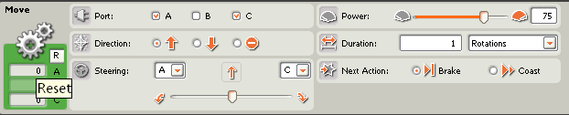 (5)
This instructs the Robot to go forwards until it meets the next yellow/green line.
Reaching the second green/yellow line.
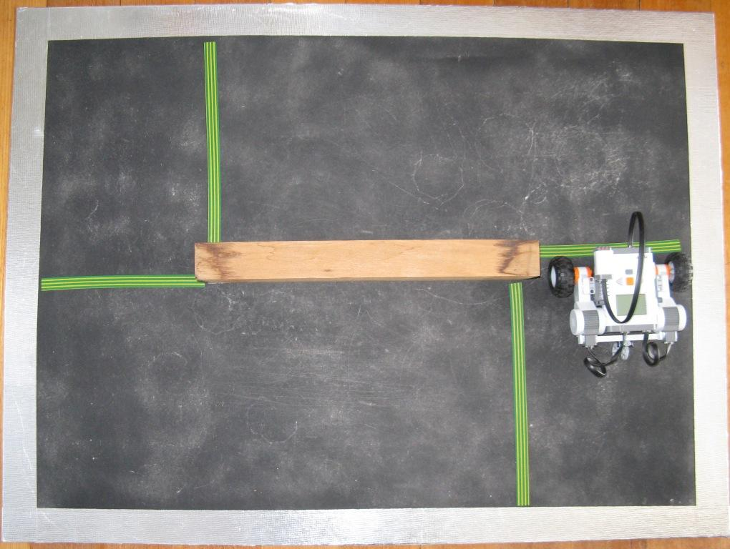
You can probably now see the reason for the positioning of the green/yellow lines. The task of completing the next quarter of the course is almost the same as it was from the last line (forward, turn left 90 degrees, forwards), the exception being that the last “forwards” command will have to send the Robot on a longer straight course.
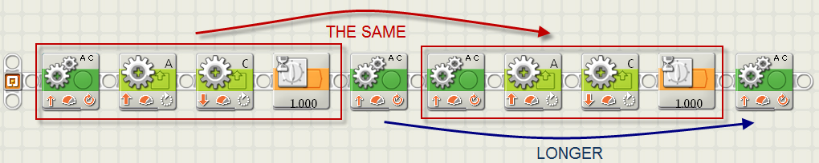
The control panel of the last two-motor command could be something like:-
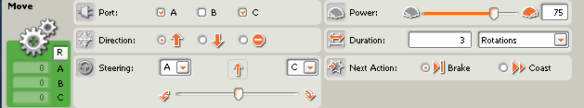
The next half-lap is identical to the one above, so either the 10 commands could be repeated. Or they could be placed in a loop, as shown below.
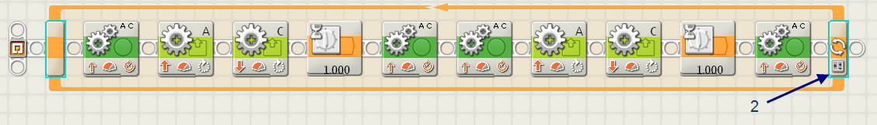
The command panel for the loop could be:-
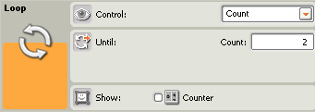
These commands will direct the Robot to complete one lap of the race course.

Started by sound.
Next we can pull down a conditional loop from the menu, as shown below:-
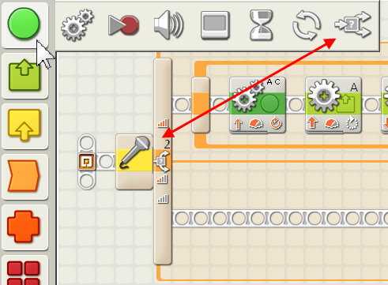
The command line for the conditional loop could be:-
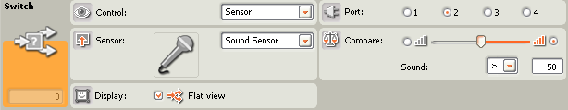
This conditional loop has the effect “IF there is a loud noise that registers as greater than 50, THEN DO whatever is in the top line of code, OTHERWISE DO whatever is in the bottom line of code”.
This will work fine if there is a loud noise in the (approximately) 1/100th of a second that the program takes to run – but we would like it to keep checking for longer than 1/100th of a second – so we place it in an infinite loop, as shown below:-
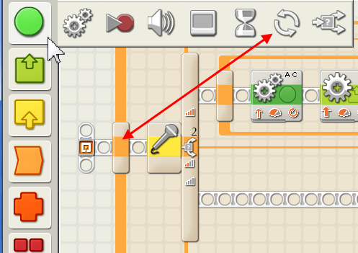
The loop having a command line like:-
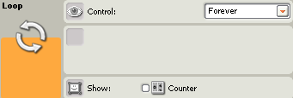
The whole programme that teaches the Robot to complete one lap of the course will look like the image at the top of the next page:-
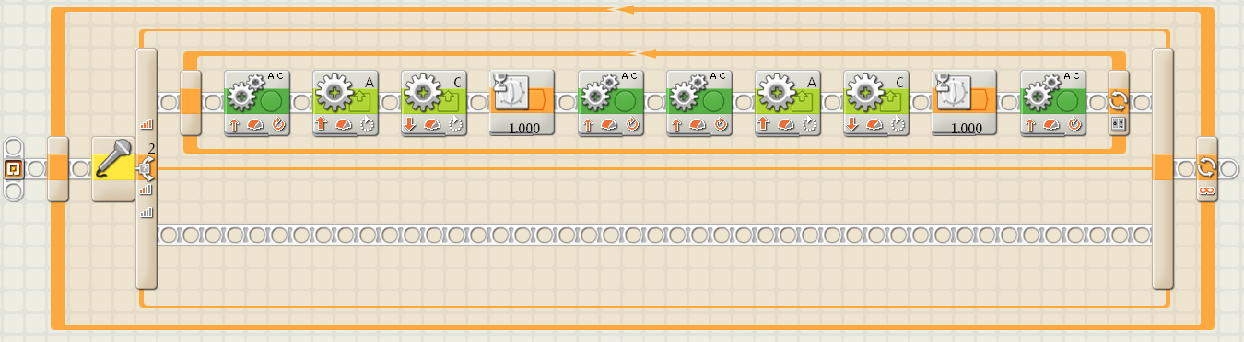
Racing
The classes I mentor often have about 30 pupils. To allow each a chance to complete this Challenge, and then race against other teams, I usually have to restrict the race to one lap – otherwise we would run over the 2-hour time limit for the session.
If you have fewer students, you may be able to extend the race duration. However if your students use Robot2 together with this course, be aware that this Challenge is a difficult task on an arena this small with a Robot as large as Robot2.
Use of a larger arena, a longer session time limit, and/or a smaller Robot, may make it quite practical to run races longer than one lap at this stage of the student’s skills.
In later Challenges, when the students have gained more experience, we run longer races, but we have found we are scrambling to finish within the session time limit if these races are longer than one lap at this stage of the student’s development – but our experience may not be the same as yours - do not be afraid to use these notes as only a general guide, and deviate from them as often as you need to make the session more fun for your students; fun is really important!…

