Mentor Notes – Robot Racing (Challenge 22)
Summary: These notes have four sections. The first provides a link to a version of this Robot Racing Challenge in Word format. The second provides some Internet links to background information relating to Racing. The third provides links on approaches to teaching the Racing Robot how to behave. The fourth provides background information on the materials used to construct the Robot Racing Arena.
Robot Racing Challenge – 2-page format
You can access a two-page version of this Robot Racing lesson in Microsoft Word 2003 format by holding down the Ctrl key and left-mouse clicking here. This version will take a little less paper than printing out the Web format of this lesson.
Robot Racing Background
The Challenge mentions Marcos Ambrose, V8 supercar racing, and NASCAR racing in the context of Robot Racing. Since your students may know more about these than you do, perhaps some background may be useful.
Marcos Ambrose was born in Launceston, Tasmania on September 1, 1976, the son of Ross Ambrose who was the well-know co-founder of the Van Diemen formula ford chassis construction organisation (why Van Diemen? Click here). Marcos has had a background with four Tasmanian Kart championships (which celebrate their 50th anniversary on 8th March 2009), one Australian Kart championship, he raced in Europe for a while, returning to mainland where he stunned the V8 Supercar racing fraternity by qualifying on pole (that is, fastest) in his first V8 supercar race. He won the V8 championship in 2003 & 2004, and later went to America. Marcos’ website is here.
V8 Supercar racing are racing cars that are meant to look like ordinary street cars, but are in reality highly specialised racing machines. They have a 5-litre V8 engine, and traditionally are grudge matches between teams of Holden and Ford cars. They will have a series of 15 races in 2009, one being in Tasmania (29th to 31st May 2009) and one overseas (Bahrain). Some cynics suggested that this series was an attempt to get an Australian NASCAR-like series going, and there do seem to be some surface similarities, but fans will probably tell you the two series are poles apart.
NASCAR (National Association for Stock Car Auto Racing ) are “stock” (supposedly near standard) cars that race in a very competitive series in America. They are supposed to look like ordinary American cars as this is supposed make the fans identify with their make of car.
The series has been criticised for the lack of similarity between the cars racing and true “stock” cars. A long Wikipedia article on NASCAR is here.
Robot racing comes in quite a few forms. A 2008 video of autonomous model robot racing (neither drivers nor remote control) can be seen here. Details of the Canadian annual competition can be seen here.
The most unexpected Robot Racing reference occurred in Qatar, where Camel racing is highly fancied, and there has been a lot of criticism of the child jockeys (as young as 4, and underfed to keep their weight down) used in the sport - so they are trialling Robot Jockeys…
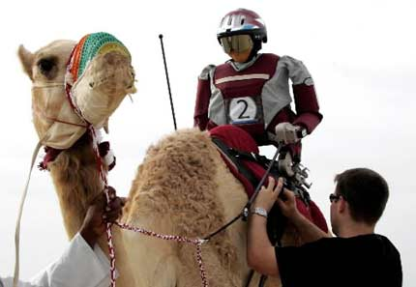
A robot jockey is mounted on a camel during an exercise near Doha. Photo: AFP
Teaching your Racing Robot
There are several approaches that are useful when you are looking at teaching Racing Robots how to behave.
NXT-G: The main approach, and the approach suggested by Lego as being the easiest to learn, is to teach your Robot how to behave using the NXT-G language. To access Mentor notes about using NXT-G for Challenge 22, Robot Racing, hold down the Ctrl key and left-mouse click here.
RoboLab: The older approach, previously used by Lego, is to use RoboLab. This works for both the present Lego NXT and the older Lego RCX robots. It is icon-based, like NXT-G, is generally regarded as being harder to learn than NXT-G (but within the capabilities of Grade 5 & 6 students). It currently has the advantage of providing faster responses than NXT-G. Mentor notes are not currently available for using RoboLab for Challenge 22, Robot Racing, but may be made available if there is a demand for them.
RobotC: The other main approach is to use RobotC. This is a text-based computer language, being generally regarded as being more appropriate for higher levels of secondary school, perhaps grades 9 & 10. It offers the fastest response of any of these three languages, but is the more difficult to learn. Mentor notes are not currently available for using RobotC for Challenge 22, Robot Racing, but may be made available if there is a demand for them.
Construction of the Robot Racing Arena
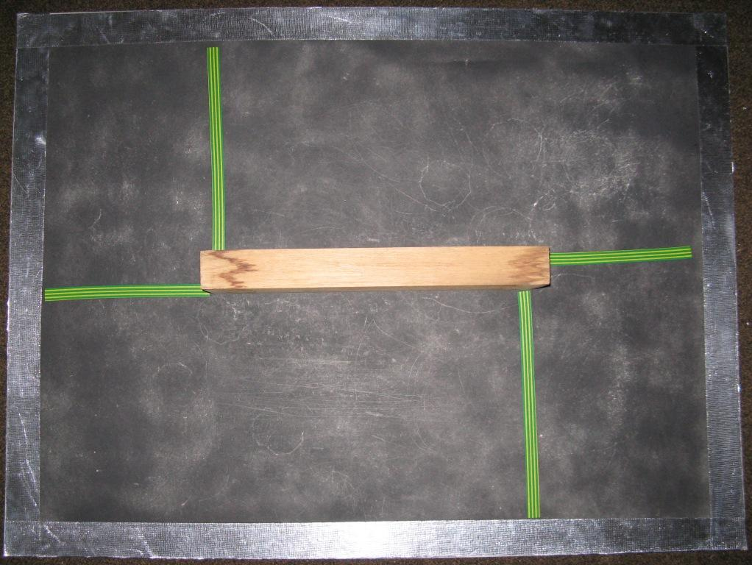
Uses: Use for Robot Racing (Challenge 22). The image above is of a rather worn arena that has had three terms of use across three schools - but still seems to work OK!
Construction: I used a straw board [1] with taped start/finish lines. The start/finish lines were electrical tape [6]. In the centre of the race track I placed a piece of wood to give the students some experience of Robot behaviour when meeting a wall at a slight angle (the Robot will often try to climb up the wall, and may even fall over). The piece of wood was an off-cut about 17 inches (430mm) long, 4 inches (100 mm) high and 2 inches (50 mm) wide. None of these dimensions are critical, except that if the wood is much longer than 17 inches, there may be insufficient space for the Robots to navigate around it.
The race track shown above has silver sides, to allow it to also serve in a Challenge 26 – the silver sides are not necessary for Challenge 22.
To make this a dual purpose Arena (Challenge 26 as well as Challenge 22), I sprayed the Arena with matt black paint [2] and rimmed it with silver tape [3]. This gave me light sensor calibration readings of about 70 in the silver area & 25 in the black area when new and about 35 when worn (the readings you will get in your arena will almost certainly be different). This gap between reading values is big enough for student’s robots to operate well even if the students are sloppy with their light sensor calibrations. The green/yellow electrical tape shown above gave a light reading of about 45, again sufficiently different for this to be used by students, if they so desired; (the tape positions are such that a Robot using a light sensor could use the green/yellow line as a signal to turn left.
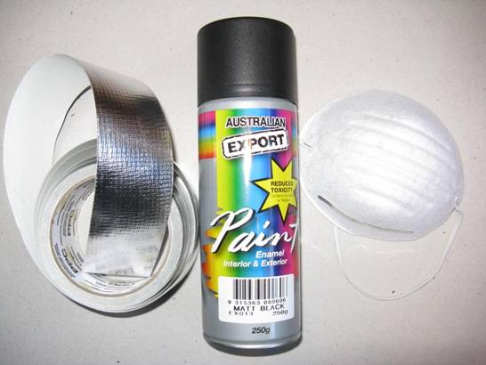
If you decide to make an arena, also get a mask (see illustration above) from the chemist’s or similar shop to use when you spray-paint the strawboard, so that you do not breath in spray paint particles, (these particles can’t be good for your lungs).
Other options? The original suggestion from Carnegie-Mellon University (see link in the “About” section of this web site) was for a 3 feet by 3 feet arena. This size proved difficult to find in a form that was a reasonable price (that is, as dirt cheap as possible!) The strawboard was a the best substitute I could find, 1050 mm by 800 mm (3 feet 5 inches by 2 feet 7 inches). A hint- don’t use a gloss paint on this board – I tried a gloss red and it was absorbed very patchily - the board looked as if it had measles – ugh!
Regarding a substitute for the strawboard, if you have a tip shop near you, then it is worth a look as these recycling centres at the local refuse dump as they can be a rich source of really cheap material. Other centres that recycle building material could also be worth checking. If these do not prove successful, your next bet could be a building material supplier.
At a building material supplier an option is Masonite sold as a blackboard. This has a nice matt black surface, but I could not find any pieces available near the 3 feet by 3 feet size – you may have more luck.
If you have facilities for chopping up large sheets of building material (I haven’t) you could look at material like an MDF white backing sheet 2400 mm by 1200 mm (6 feet 10 inches by 3 feet 11 inches) [4]. In this case you would use black cloth tape [5] to edge the arena. An ordinary 3mm MDF board of the same size is about 2/3 the cost of the white-surfaced MDF board, but you would have to factor in the price of the paint to get a matt black or white surface for your arena. Which way to go? - Up to you…
Good luck with your fossicking!
Obtainable Where?
The following information is included to provide an idea about price & availability - it is not intended to be a recommendation for any particular commercial institution. The prices were current at the end of 2008.
[1] The straw board was obtained from an Art supplies Store; (in my case “Artery”, Collins Street, Hobart, Tasmania $4.95).
[2] The matt black spray can paint was obtained from a "remainder" store; (in my case Chickenfeed, Hobart, Tasmania, $3:00; enough for blackening two strawboard sides).
[3] The 48 mm. wide (approx. 2 inches) self-adhesive CSR Bradford Insulation Aluminium Foil Tape was obtained from a hardware store, (in my case Kemp & Denning, Hobart, Tasmania, $14.99 for a roll long enough (20 metres) to last you for a really long time…) Subsequently I have also found a cheaper version at a remainder store (in my case Chickenfeed; Aluminium tape 48 mm. wide by 10 meters long $2.99).
[4] The 3 mm MDF white backing sheet mentioned above can probably be obtained from a hardware store; (in my case I saw it in stock at Kemp & Denning, Hobart, Tasmania, for $19).
[5] This self-adhesive black cloth tape (48 mm by 4.5 meters, approx. 2 inches by 5 yards) was obtained from a hardware store; (in my case at Kemp & Denning, Hobart, Tasmania, $2.16).
[6] This electrical tape was obtained from a hardware store, I've forgotten the price, but think it was about $2.50. It need not be green/yellow, any colour that gives a light sensor reading that is more than 10 different from the light sensor reading in either the silver or black portions of the arena should be fine.

