Lucky or Unlucky – Mentor Notes

Purpose of this Challenge.
The main purpose of this Challenge is to introduce the idea of “loops”. A “Loop” is a shell that encloses a piece of code, allowing that code to be repeated either a specific or an undetermined number of times.
In this case, code that sends the Robot along one side of an imaginary square, is repeated 4 times to send the Robot around a complete square – the complete square in this case being one half of the shape of the number “8”.

Lucky or Unlucky?
The Challenge is framed in the context of “lucky” and “unlucky” events, mainly numbers.
It seems that events that generate emotional responses in humans are remembered particularly vividly. If the emotional response is an intensely pleasurable one, elements of the surrounding circumstances can become associated with the event, and if the circumstances include numbers these numbers can become “lucky numbers” for the person experiencing that emotion. A similar situation can occur with particularly unfortunate experiences, except that associated numbers in this case can become to be regarded as “unlucky numbers” for that person. In these cases, the numbers that are “lucky” or “unlucky” will probably vary from person to person.
If the emotion associated with a number permeates a society, that number can come to be regarded an “unlucky” by many of the members of a whole society. Such a situation reportedly occurs in China, with Wikipedia commenting
“Number 4 ... is considered an unlucky number in Chinese, Korean, Vietnamese and Japanese cultures because it is a homonym with the word "death" ... . Due to that, many numbered product lines skip the "4": e.g. Nokia cell phones (there is no series beginning with a 4), Palm PDAs, Canon PowerShot G's series (after G3 goes G5), etc. In East Asia, some buildings do not have a 4th floor. (Compare with the American practice of some buildings not having a 13th floor because 13 is considered unlucky.) In Hong Kong, some high-rise residential buildings miss ALL floor numbers with "4", e.g. 4, 14, 24, 34 and all 40-49 floors. As a result, a building whose highest floor is number 50 may actually have only 36 physical floors.
In Singapore during the early 2000s, Alfa Romeo introduced a new model, the 144. Nobody bought it, so they had to change the model number.”
That the number 13 is considered unlucky is better known in Western countries, many associating this with the number of disciples present at the Christian religion’s “Last Supper”; however Catherine Johnson comments that the belief goes back even further, “As far back as 1,760 BC, the Code of Hammurabi omitted a 13th law and to this day, the superstition persists.”
The practice of omitting “unlucky 13th” floors from buildings can potentially cause problems, with this reference claiming that a fatal bungee jump occurred because the jumpers calculating the length of the bungee rope assumed that the building they were jumping from had a 13th floor – the video claims it didn’t.
The devil’s digits 666 come from the last book in the bible – they are “The Number of the Beast” in that book although several authorities (e.g. Catherine Johnson in the reference mentioned above) discuss the possibility of mistranslations. It is interesting that to Judaism the number 666 is considered holy…
Anyway, the above should be enough for you to give a bit of a background to “lucky” and “unlucky” numbers. As always, there is a feast of information on the Internet if you want more…

Code used.
The code used in this version of the Challenge is Lego’s currently recommended language, NXT-G. This is the language supplied as standard with the “retail” or “home” version of the NXT kitset. It is also available in a different educational version that omits the directions for building several Robots (present in the retail kit), replacing these building instructions with extra tutorial help on the language NXT-G.

NXT-G Code Extensions.
The code given in this Challenge aims to teach the Robot to traverse a “figure 8”. This code only contains one loop. This is deliberate, as a loop within a loop is a bit complicated for my students at this stage. If yours are more advanced, a code sample like the following could be used.
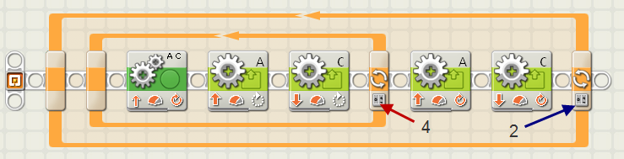
This would give the same “figure 8” as the last code in this Challenge, with the exception that there is an extra twirl at the end on of the run.
As a further extension, if the last two “A” and “C” motor controls are set for a 90 degree turn (rather than the 180 degree turn used in this Challenge), and the final loop was changed from a count of 2 repeats to a count of 4 repeats, a “lucky 4-leaf clover” could be traced out by the Robot – there is good luck everywhere in this challenge, isn’t there? ☺.
Arena – Not essential – I used a sheet of A4 paper only to make the videos of the Robot clearer.

