First Challenge – Your first Robot using Lego MindStorms NXT.

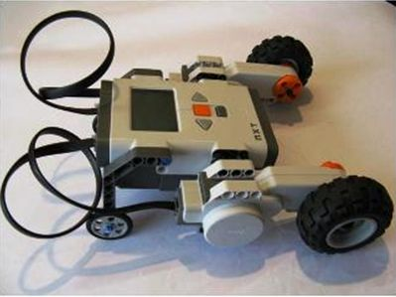

This tutorial Challenge is all about building your first robot. It helps you build a robot that will look like the one in the picture to the left.
Go to it!

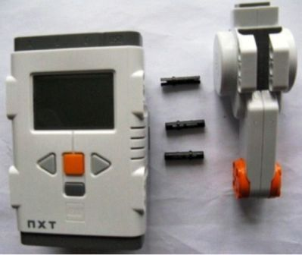

1 - Adding a Motor
Find the LEGO pieces pictured to the left, and then assemble them so that the result looks like the picture on the right.
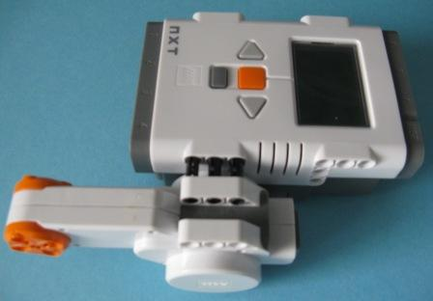

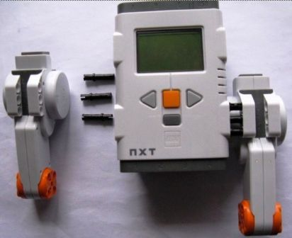
2: Adding a Second Motor
Find the LEGO pieces pictured to the left, and then assemble them so that the result looks like the picture on the right
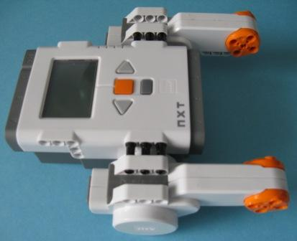

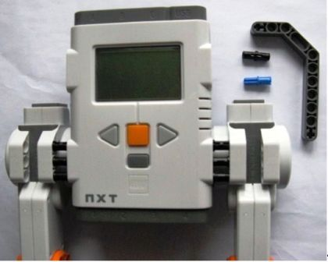

3: Adding a Rear Wheel Support
Find the LEGO pieces pictured to the left, and then assemble them so that the result looks like the picture on the right
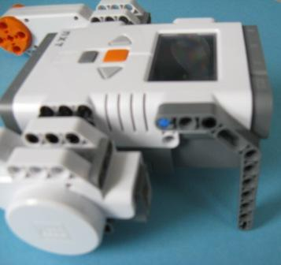

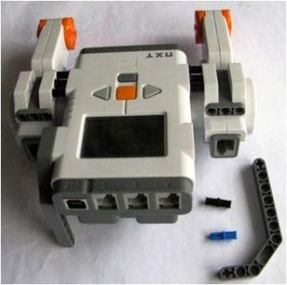

4: Adding a Second Wheel Support
Find the LEGO pieces pictured to the left, and then assemble them so that the result looks like the picture on the right
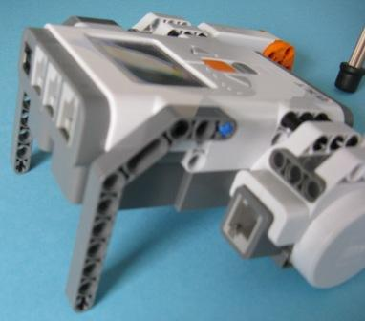

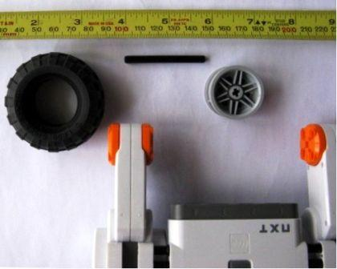

5: Attaching a Wheel to a Motor
Find the LEGO pieces pictured to the left, and then assemble them so that the result looks like the picture on the right
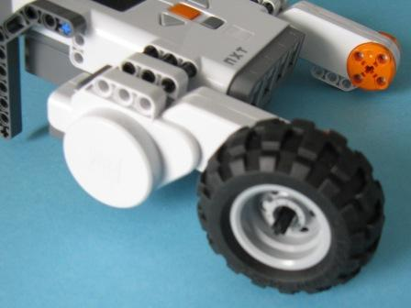

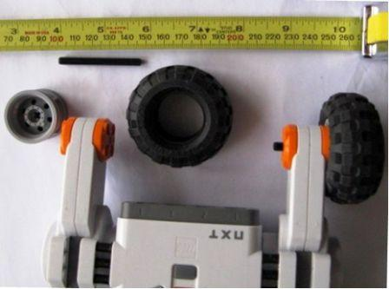

6: Attaching a Second Wheel
Find the LEGO pieces pictured to the left, and then assemble them so that the result looks like the picture on the right.
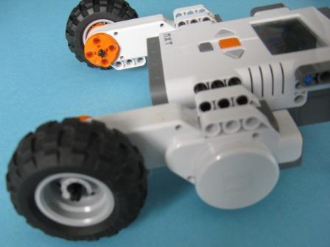

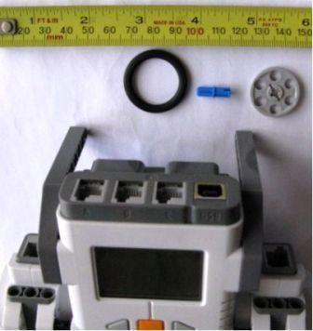

7: Attaching a Third Wheel.
Find the LEGO pieces pictured to the left, and then assemble them so that the result looks like the picture on the right.
Note that the blue connecting rod goes in the second hole from the bottom of the grey beam (not the bottom hole!)
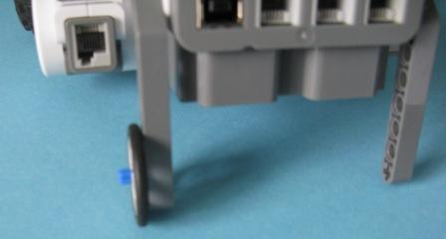

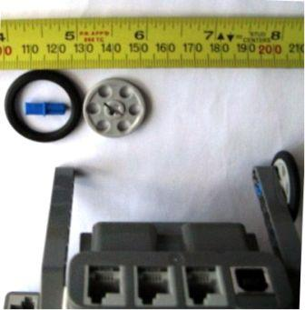

8: Attaching a Fourth Wheel.
Find the LEGO pieces pictured to the left, and then assemble them so that the result looks like the picture on the right.
Note that the blue connecting rod goes in the second hole from the bottom of the grey beam (not the bottom hole!)

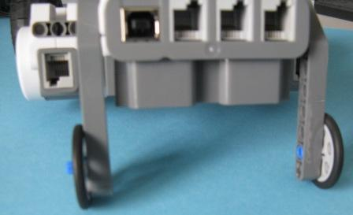

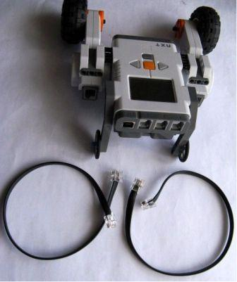

9: Connect a Motor Control Cable.
Find the LEGO pieces pictured to the left, and then plug in one cable so that the result looks like the picture on the right.
Take care! – Take a careful look at the ends of the cables and the shapes of the holes the cables plug in to before you try to connect them. - Note that the cables only plug in one way around. Do not force the cables if they do not seem to fit - they should go in easily if you have them the right way around before you try to insert them into the appropriate holes.
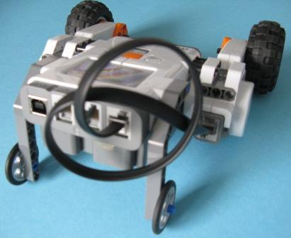

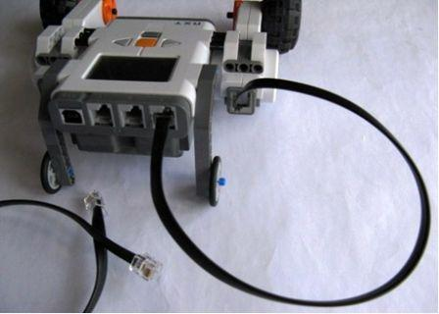

Step 10: Connect the Second Motor Cable.
Find the cable pictured to the left, and then plug it in so that the result looks like the picture on the right.

Does your Robot look like the Robot to the right?
If it does, go on to the next Challenge to find out how to teach your Robot to do what you want it to do...
If it doesn't look like this, click on some of the Steps in the panel to the left of this picture, and check the way you have put your robot together...

