Lego MindStorms EV3 Robotics Workshops

Suitable for teachers interested in
Years 4-10
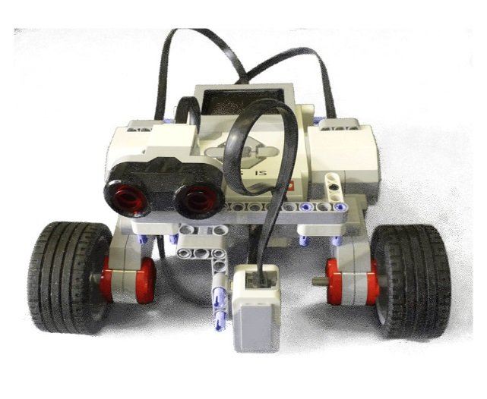
This Google-supported workshop introduces the new LEGO Mindstorm EV3 kits. It will provide Primary and Secondary Teachers an opportunity for hands-on experiences with beginner level robotic building and programming using the new EV3 MindStorms kits. Working in pairs, teachers will have the opportunity to assess the feasibility of integrating these resources into their Primary and Secondary classroom teaching plans.
More about the kits at: (http://shop.lego.com/en-AU/LEGO-MINDSTORMS-EV3-31313 ).
The workshops are organized by Ying Chen of School of Computing and Information Systems (CIS) (http://www.utas.edu.au/computing-information-systems/home), with assistance from Dr. Graeme Faulkner, a retired academic who has assisted many robotics sessions in Schools, and mentored several winning RoboCup teams from Tasmania.
The workshop is sponsored by Google Australia (https://www.google.com.au/). It is a professional learning workshop that is open to Tasmanian Primary and Secondary School Teachers. Google’s support means that attendance at these workshop is free.
This workshop will be run in the three campuses of the University of Tasmania.
Campus | Venue | Date | Time | Participants
Hobart | The Centenary Building, Room 272 | 20/11/2013 | 2pm – 6pm | 20
Launceston | School of Computing and Information Systems Building, Room V195 | 26/11/2013 | 2pm – 6pm | 16
Cradle Coast | Room B1.25 | 28/11/2013 | 2pm – 6pm | 20
Please note that due to the limited space in the 3 computer laboratories, there is a maximum number of participants that we can enrol for each venue.
Workshop Schedule
2 pm | Welcome and networking
2:15 pm | login for web resources and workshop briefings
2:30 pm | Hands-on session with robot building and programming
4 pm | Mini coffee break and networking
4: 20 pm | More hands-on session with robot building and programming
5: 40 pm | Wrap up and feedback
 | Note: A representative from Google will be coming to the Hobart session, resulting in a small modification of this tentative schedule.

University of Tasmania Workshop 2013 Registration Form
To register your interest in the workshop please complete the following form and return it via email to ying.chen@utas.edu.au or Fax: (03) 6226 2913
First Name:
Last Name:
School:
Teaching Area:
Year Level:
Previous Experience with robotics, eg LEGO Mindstorms NXT or RCX etc., If yes please specify.
E-mail:
Phone:
Address (optional):
Please circle the venue below for your participation.
Hobart,  Wednesday, 20/11/2013,  2pm – 6pm,  Centenary Building,  Room 272 | Launceston,  Tuesday, 26/11/2013,  2pm – 6pm,  School of Computing and Information Systems Building, Room V195 | Cradle Coast,  Thursday, 28/11/2013,  2pm – 6pm,  B1.25
Please specify your requirements for workshop (including but not limited to catering):

